Parsing Explained – Computerphile
Breaking up sentence structure into its components parts under the direction of grammar, so that grammar is the rule for your langauge.
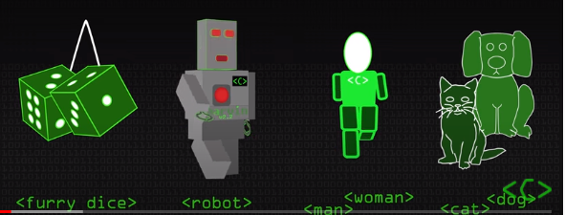

Software YACC: produces bottom up parser. It tries to take the longest Substring of a word and reduce.
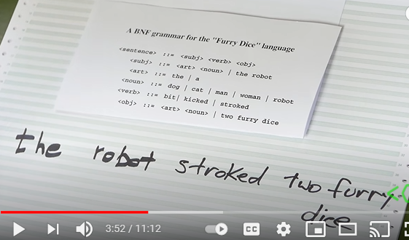
For e.g it reduces “the robot “ into <subj> .
This thing u looking here, is built up on the stack its called the handle.
